**Proposed actions and questions based on TOR**

1. **Support coordination and operationalization of the GHHIN (e.g. organizing and follow up from teleconferences with steering committee, active coordination with NOAA and other partners on keys activities in the work plan).**

* Initial contact with Hunter?
* Will this link in with the Global Heat Health Forum 2017?

1. **Develop synthesizing technical paper on similarities and differences in global extreme heat prediction and preparedness systems across timescales (weather, S2S, and decadal) that will provide the framework for the GHHIN to track HHEWS approaches, and establish indicators of risk and adaptation that can be part of a GIS dashboard and the country profiles. Tasks include developing structure, propose data collection approach, organize existing data, and produce first draft of technical paper for review and feedback by the GHHIN Global Advisory Committee.**

* Scope of the paper? Does it cover as many countries as we can find, or is it more focussed (ie WHO climate and health country profiles)?
* How to build on [Lancet Countdown metrics](http://www.thelancet.com/cms/attachment/2087670434/2074631017/mmc1.pdf)? Labour productivity metric to be included (e.g. wet bulb temperature/humidity) or temperature alone?
* Scrutinise the skill of the forecasts for early warning systems, or just include if they exist? (from pg. 30 of [SACSUF](http://www.wmo.int/pages/prog/wcp/wcsp/rcofs/sascof/health/documents/1st-South-Asia-Climate-Services-Forum-for-Health.pdf))
* Building on table 4 pg 28 of ‘Heatwaves and health…’?
* Is there any point trying to standardise the definition of a heatwave, as could be relevant for 3 below (could make a heatwave definition and compare)

1. **Frame and draft subsequent technical paper using initial findings from cataloguing HHEWS and combining with projecting of future temperature for those cities (using select cities or countries representative of different approached) to show how, according to the heatwave trigger of each HHEWS, how dire or manageable the situation may be in the future.**

* Locations that would be preferred? (e.g. South Asia as priority?)
* Timescale (e.g. 2050 and 2100?)
* Regional climate models in mind because of say existing relationships? (CORDEX?)
* Malawi methodology is to use MAGICC + SCENGEN (‘*This task was done in two stages. Firstly, climate change projections of temperature and precipitation were generated using General Circulation Models… The task of generating climate change scenarios of temperature and precipitation involved the application of an ensemble of General Circulation Models (GCMs) for the entire country (GoM, 2011; GoM, 2002). This was complemented by results presented by the IPCC in its Fourth Assessment Report (IPCC, 2007a), the UNDP Report (McSweeney, New, & Lizcano, 2008), Intergovernmental Authority in Development (IGAD) and ICPAC (IGAD Climate Prediction and Application Centre) report of 2007’*
* Will need to establish how to derive daily values of CMIP5 climate projections

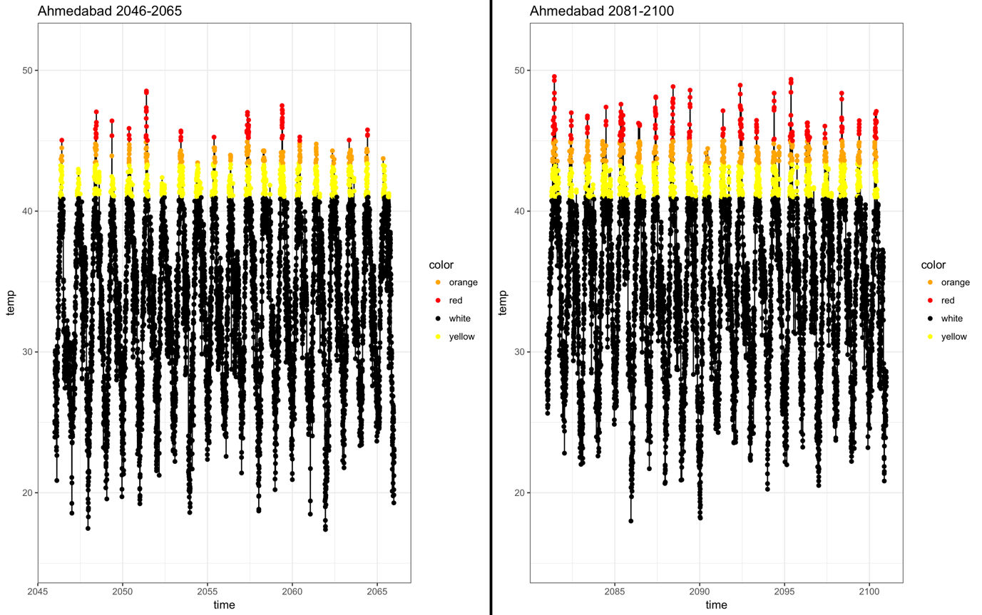

**WORKFLOW in R**

* Codify definition HHEWS and triggers for respective countries/subnationally/cities
* Process each regional climate model ensemble (from CORDEX/MAGICC+SCENGEN or other GCM via <http://www.ipcc-data.org/sim/gcm_monthly/AR5/index.html> using KNMI Climate Explorer) using HHEWS trigger for defined region
* Compare normal period (e.g. 1981-2009) to future period (e.g. 2050/2100) for number of heatwaves or heat events

1. **Help support the formation of the South Asia HH Action Network (SAR-HHAN) node, through mapping, outreach and coordination with regional actors, building on existing activities, needs and draft regional action plan identified at the 2016 South Asia Climate Service User Forum.**

* Draft regional action plan as [follows](http://www.wmo.int/pages/prog/wcp/wcsp/rcofs/sascof/health/csf-health.php)?
  + ***Research*** *To better understand extreme heat exposure vulnerability, exposures, impacts and effectiveness of preventive measure.*
  + ***Data, Information and Product Development*** *To improve extreme heat prediction products and warning systems for information dissemination, interoperable data management platforms, and improved measurement of indicators.*
  + ***Partnerships and Communications*** *To identify and provide outreach to a wide range of relevant actors, assist with quality assurance of EHE warnings, and promote opportunities for sharing and communication of research, evidence and action*
  + ***Capacity Development*** *To develop technical guidance, mobilize training opportunities, and enhance networking and exchange with experts*